
Company
Logotype

Cone Beam Computed Tomography- Report



Porur Dental X-rays & CBCT

Patient Name : Miss. Shruthi Sekhar | Date of Report : 19.07.2024
Age/ Gender : 27 years/ Female | Region of Interest : CBCT Maxilla Sectional
Referring doctor: Dr. Lakshmi | Indication : Swelling 2nd quadrant.
Clinical Notes: Nil
PATIENT INFORMATION

CBCT- Sectional Maxilla provided
CBCT – IMAGE DETAILS

RADIOGRAPHIC INTERPRETATION

- The tooth 23, 24, 25 are present with hyperdense crown structure.
- In relation to the labial aspect of 22, presence of diffuse area of hypodensity causing loss of labial cortical bone evident. Extreme thinning of labial bone in interdental region of 22, 23.
- The alveolar ridge in relation to 23, 24, 25, 26, 27 is present with normal trabecular pattern.

RADIOGRAPHIC IMPRESSION

- Crown: 23, 24, 25.
- Bone dehiscence: 22 region

Kindly correlate with clinical findings


IMAGES FOR REFERENCE

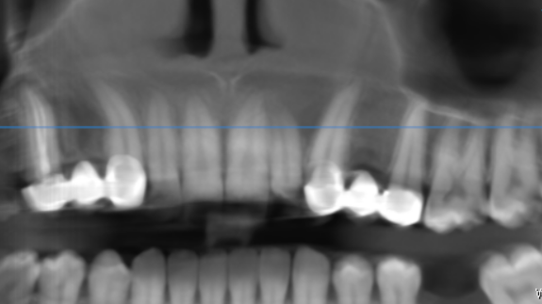

3-DIMENSIONAL VIEW

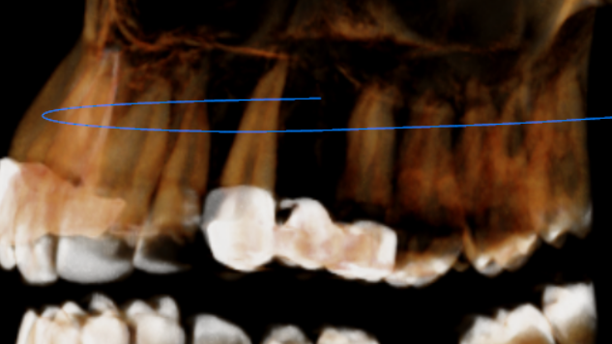

CROSS SECTIONAL VIEW
46 region
22 region

Loss of labial bone irt 22
Tooth 21

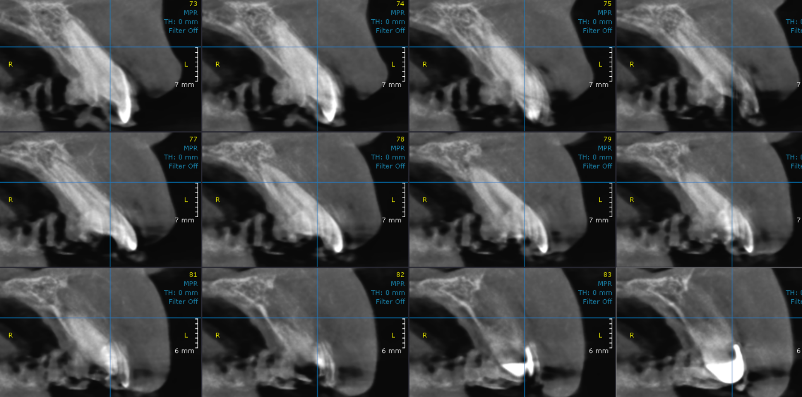
Thinning of bone in interdental region of 22, 23

**** End of report ****

